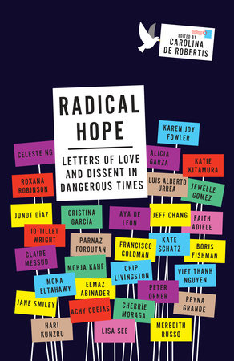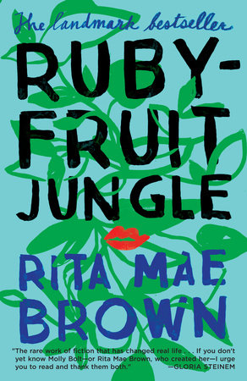  ADULT BOOKS  Boy Erased  Garrard Conley  Ruby-Fruit Jungle  Rita Mae Brown  Planetfall  Emma Newman  The Life and Death of Sophie Stark  Anna North  Prudence  David Treuer  Boy Meets Boy  David Levithan  Gender Outlaw  Kate Bornstein  Radical Hope  Edited by: Caroline De Robertis  When Katie Met Cassidy  Camille Perri
  VLA Inclusion Committee
  About Us
  The VLA Inclusion Committee will advance awareness and improve service to a wide range of often underserved populations in Vermont by aggregating and disseminating resources related to collection development, literacy, the digital divide, and social services.
  vermontlibraries.org/inclusion
  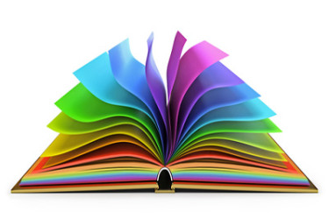
  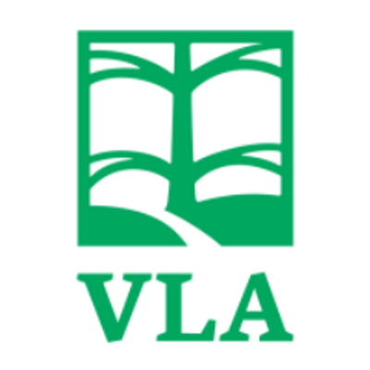 | vermont library association  vermontlibraries.org
  LGBT BOOKLIST
  Created by the Inclusion Committee
  vermont library association
    - 
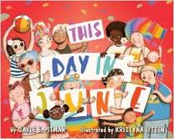  PICTURE BOOKS  Promised Land  Adam Reynolds and Chaz Harris  This Day in June  Gayle E. Pitman  Pink is For Boys  Robb Pearlman  When You Look Out the Window  Gayle E. Pitman  Julián is a Mermaid  Amy Fabrikant and Jennifer Levine  Jerome By Heart  Thomas Scotto  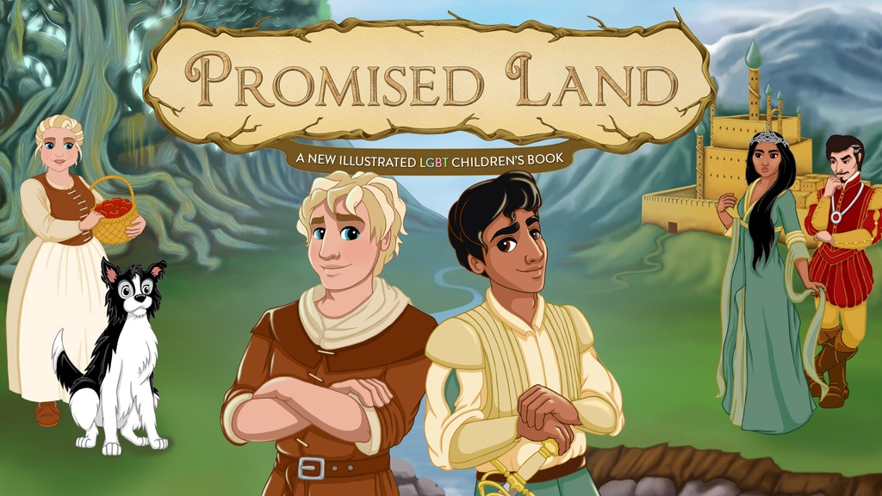 | CHAPTER BOOKS  The Best Man  Richard Peck  The Other Boy  M. G. Hennessey  Star-Crossed  Barbara Dee  The Pants Project  Cat Clarke  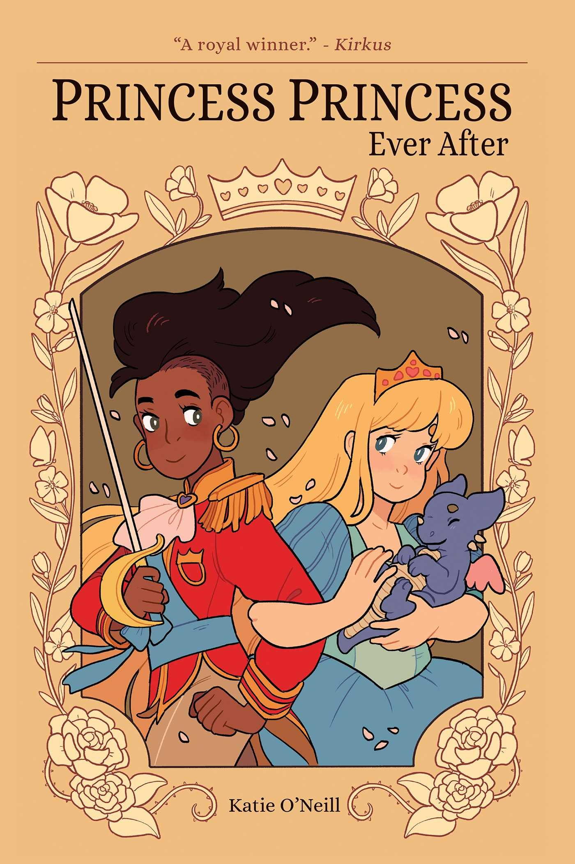  Princess Princess Ever After  Kate O’Neill  The Parker Inheritance  Varian Johnson  Lily and Dunkin  Donna Gephart  The Magic Misfits  Neil Patrick Harris  The Witch Boy  Molly Ostertag | 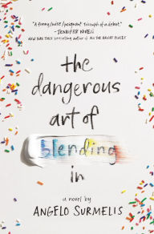  TEEN BOOKS  The Dangerous Art of Blending In  Angelo Surmelis  All Out: The No-Longer-Secret Stories of Kick-Ass Queer Teens  Edited by: Saundra Mitchell  People Like Us  Dana M. Mele  Let’s Talk About Love  Claire Kann  The Summer of Jordi Perez  Amy Spalding  The Unbinding of Mary Reade  Miriam McNamara  White Rabbit  Caleb Roehrig  Anger is a Gift  Mark Oshiro  Sometimes After Midnight L. Philips

